KEYAZ CONSULTANCY
MIDTERM II EXAMINATION 2023
Age Group (4 – 5 years): MIDDLE CLASS
Learning Area 4: Mathematical Concepts

My name is ______________________________________________
School: _____________________________________________________
- Count and write.
A set of __________ chairs.

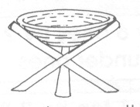
A set of __________ stools.

A set of ________ flowers.

A set of _______ tins.

A set of _______ pot.

- Draw for the number.

5

1

4

3

0
- Write the number between
0 _____ 2
3 ____ 5
6 _____ 8
9 _____ 11
- Write the number before.
____ 1
____ 2
____ 4
____ 6
____ 8
- Write number words.
5 _____________ 1 ____________
4 ____________ 2 ____________
3 _____________
(one, four, two, five)
- Colour the smaller.

END

